Nudging a clip on the timeline
Select the clip, hit the comma key or the period key to nudge it backwards or forward on the timeline.

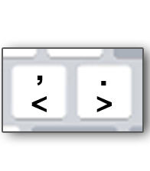
When you’re lining up your crawl:

Do this:
- Park playhead on the cut point
- Press:
  - Left Arrow → go to last frame of Clip A
  - Right Arrow → go to first frame of Clip B
- Then:
  - Tap , or . to nudge Clip B
  - Watch text alignment in viewer
👉 You’re literally “stitching” the illusion frame-by-frame

